Table of Contents

I can’t use my mouse to right click, and when I scroll up, the page actually goes down. 1

How do I capture screenshot? 3

My Mac is slow 4

Idle timeout too short and my screen locks too frequently 7

Emails not updating in Outlook client. 9

App freezes, or not functioning as it should. 10

App keeps on freezing/crashing 12

Can’t find SERVER(AFP) in the Finder. 14

App can’t print 2-sided or A3 size. 15

Safari is not responding when I click on a hyperlink. 20

When I clicked on an email address link on a website, it’s opened by Mail app composer instead of Outlook’s. 21

iPhone/Android freezes / not responding, unable to start, restart or shutdown. 23

When something went wrong and all above approaches failed. 24

# I can’t use my mouse to right click, and when I scroll up, the page actually goes down.

If you’re new to Mac and are using Apple mouse, you may find that your favourite right clicking function is gone.

Apple likes to do things entirely differently compared to Windows. Right click is not enabled on a Mac by default, you have to go to ***System Preference***:

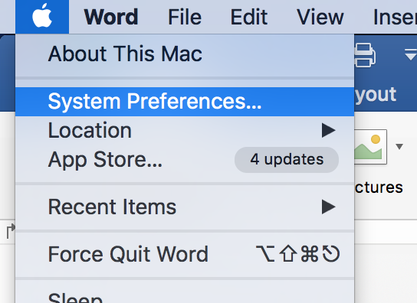

Then click on ***Mouse***:

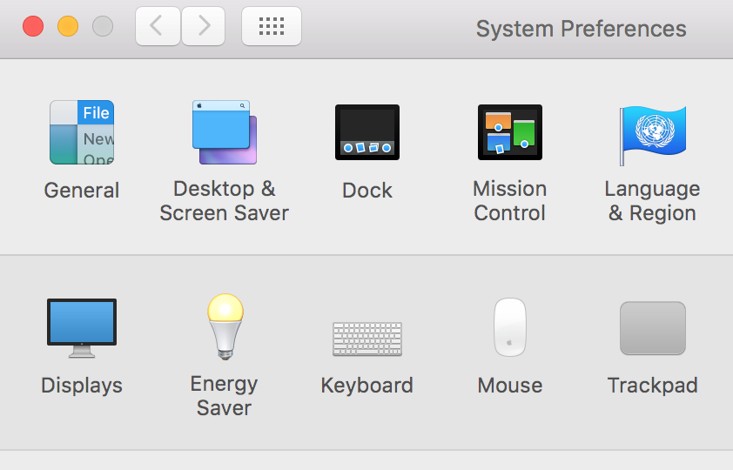

Just check the ***Secondary click*** checkbox to enable right click:

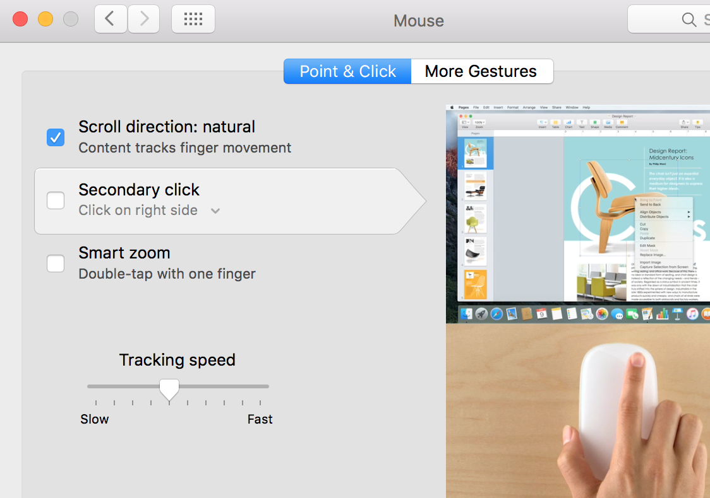

Or if you’re not using right click that often, ***control + left click*** works exactly the same as a right click.

For the scroll direction, uncheck the ***Scroll direction: natural*** option to restore Windows style scrolling.

Yup, scroll up to go up and scroll down to go down is “unnatural” to Apple.

# How do I capture screenshot?

If you want to save the screenshot to a file:

* Press ***shift + command + 4*** buttons together
* Your cursor will turn into a cross-hair
* Left click and drag the area that you’d like to capture, then release
* The image file will be saved to your desktop

If you want to save the screenshot directly to clipboard:

* Press ***shift + control + command + 4*** together (you may need some yoga practice for your fingers)
* Your cursor will turn into a cross-hair
* Left click and drag the area that you’d like to capture, then release
* Go to the app where you’d like to paste the screenshot, press ***command + v***

# My Mac is slow

The iMacs and Macbooks in the office are of various specs and some may be slower than the others.

If no other faster Macs are available, or we are not ordering new Macs, the only way is to attempt to boost the performance of your current Mac.

Unfortunately Macs can’t be safely overclocked without some accompanying risks. If it’s safe and easy, Apple would have done it in the first place.

While adding more physical RAMs or swapping the mechanical HDD with an SSD can significant speed up a computer, hardware upgrade isn’t easy too, as our Macs do not have user-accessible memory slots or hard disk bays.

So the last resort that I can think of is to use some 3rd party apps to boost the performance, but as “boosting performance” isn’t easy even for apps, the “optimization” is the better solution.

Go to ***App Store*** and try to search for keywords “*dr cleaner*”, get and install the app. If you’re asked Apple ID & password, let me know:

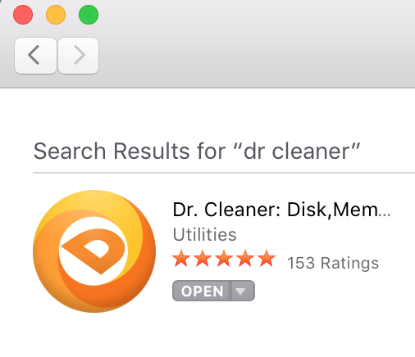

Launch the app and set permission when asked, in the top menu bar you will be able to see a number telling you how much memory your system is using.

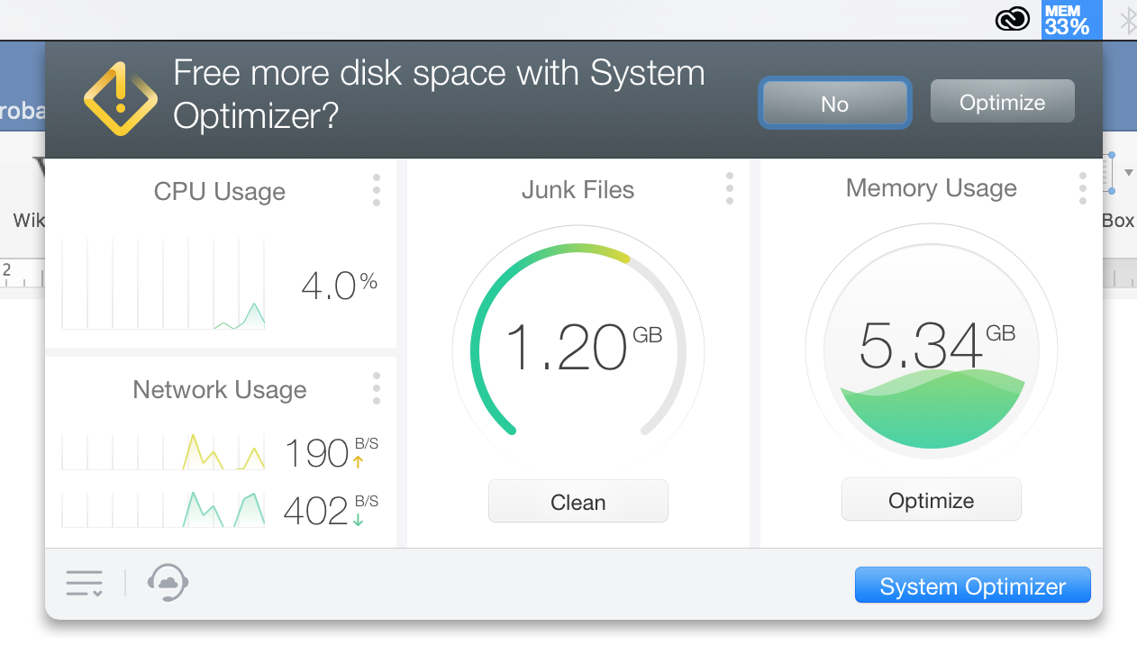

For more frequent optimization, right click on the memory utilization icon and select ***Preferences***:

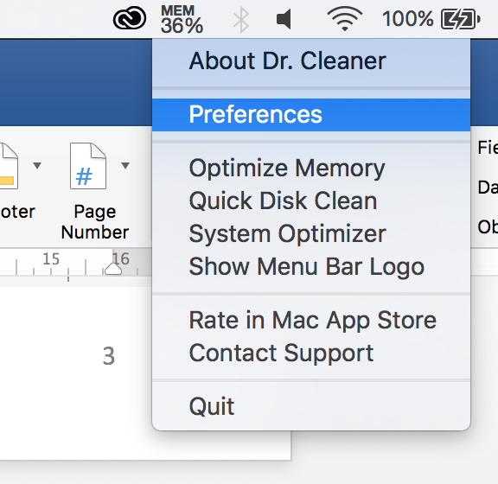

At the ***Memory*** tab, check the options to auto clean memory *when apps close*, *when available memory is low* and *after computer is waked*:

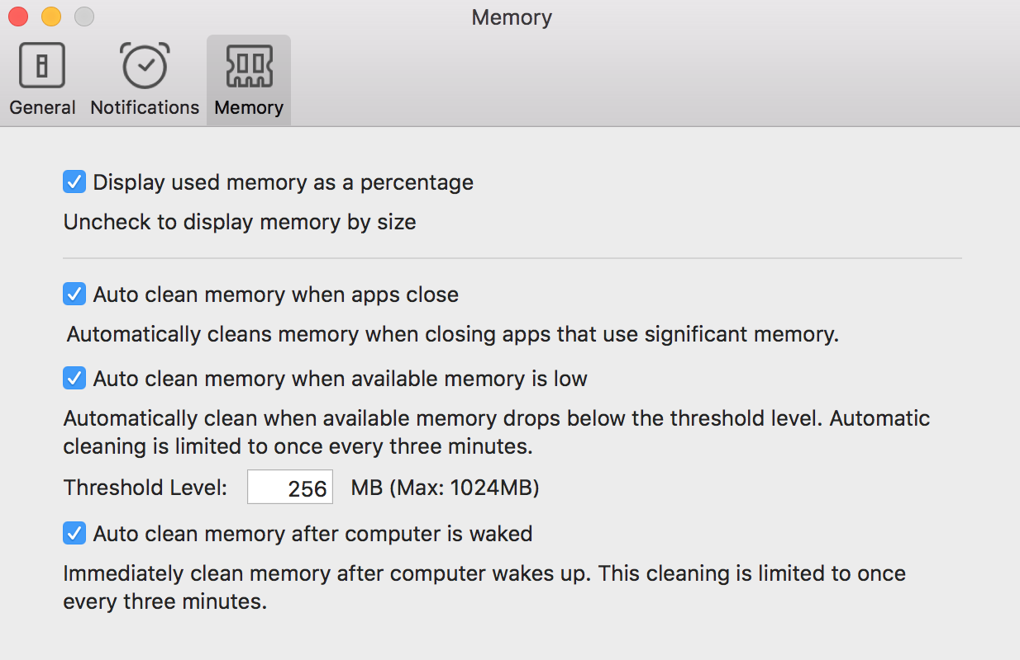

Note that it may not make a very big difference on system performance, but it’s better than nothing.

# Idle timeout too short and my screen locks too frequently

I know, you looked away for like 2 minutes and when you turned back to your screen, it’s locked, you’ll have to enter password again, frustrating.

There are two settings that can affect the screen lock time:

1. How long your Mac will turn off the screen when no activity is detected
2. How long your Mac will actually lock the screen after the display is turned off

(2) sounds like a better option as it saves power while delaying the screen lock, but some Macs in the office are managed and this option is disabled. To check, go to ***System Preferences***:

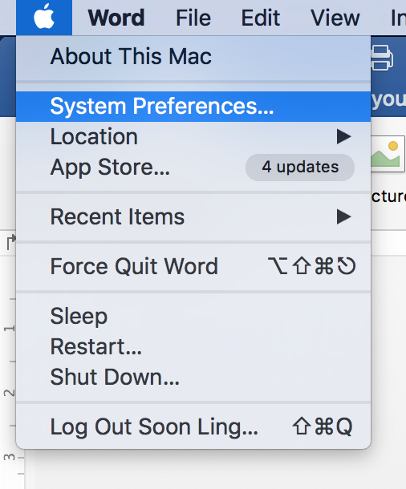

Go to ***Security & Privacy***:

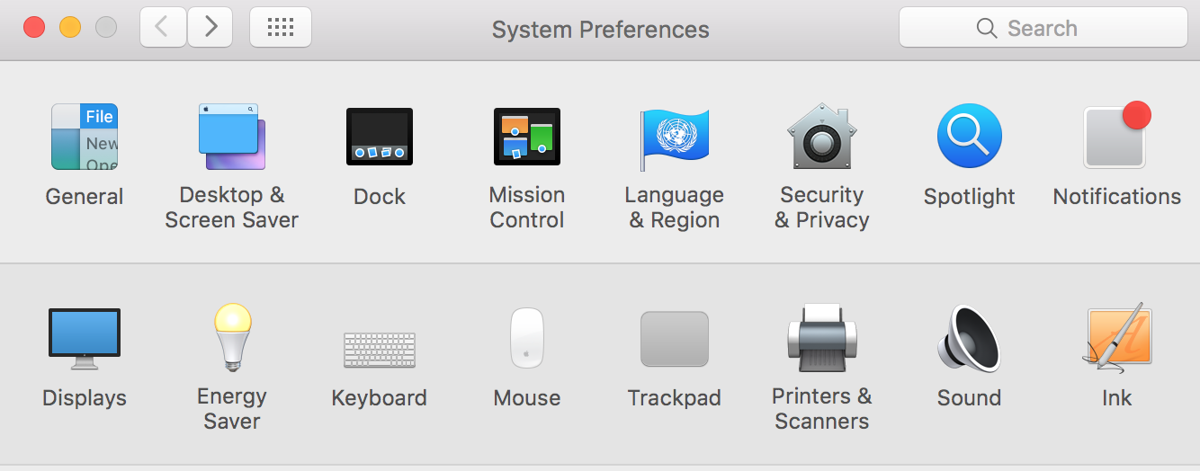

If the option to adjust the time that system will wait before requiring password is greyed out, and won’t become available even the admin password is entered, then you can’t use this option:

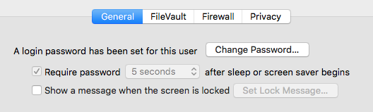

But worry not, go to ***Energy Saver*** instead:



Slide the ***Turn display off after*** bar so that your Mac will wait longer before turning off your screen (you may need admin password, let me know if you do.

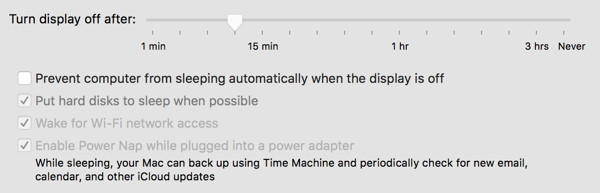

Please make your choice reasonable as if your screen takes as long as 1 hour to turn off, then your Mac can be accessed by anyone while you’re out for lunch if you didn’t put it to sleep.

# Emails not updating in Outlook client.

If you noticed that you can’t send or receive emails via Outlook client, there could be a number of reasons:

* Your Mac does not have access to internet.
* Your client has somehow messed up the password and hence disconnected with the Exchange server.

Check the status at the lower-left corner of your Outlook client, it should show that all folders are up to date and the account is connected:



If it showed that it’s not connected:



* Check your internet connection: see whether Wi-Fi is on, whether you can open a web page, etc. If not, try to regain internet access.
* Re-enter your email password as below:

Go to ***Tools 🡪 Accounts*** and enter your password in the password field, there’s no need to press “Enter” or “Ok”. Just go back to the ***Home*** tab and check the status, click ***Send and Receive*** button if necessary.

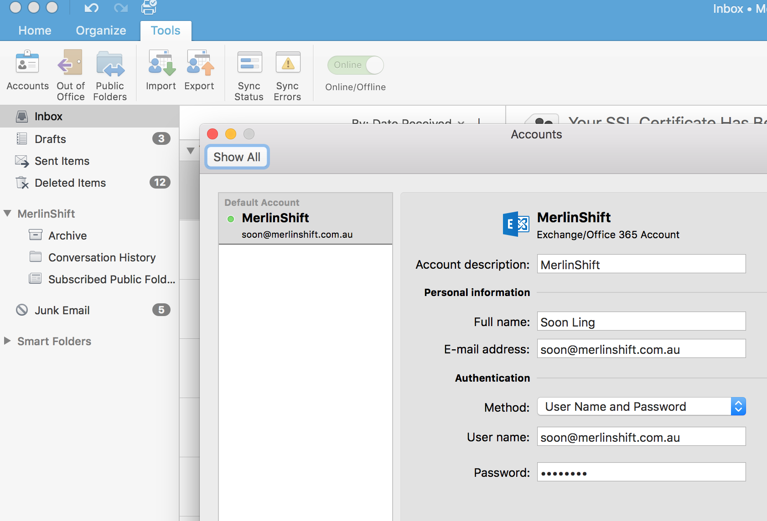

# App freezes, or not functioning as it should.

Sometimes you may experience problems with apps, including but not limited to:

* App stops responding, you keep seeing the spinning colour wheel 
* App’s behaving strange, like Excel is not printing while you tried to print something.

The easiest and dumbest way can be the most effective, RESTART it.

Note that clicking on the little cross button at the upper-left corner doesn’t quit the app, it just sends it to background:

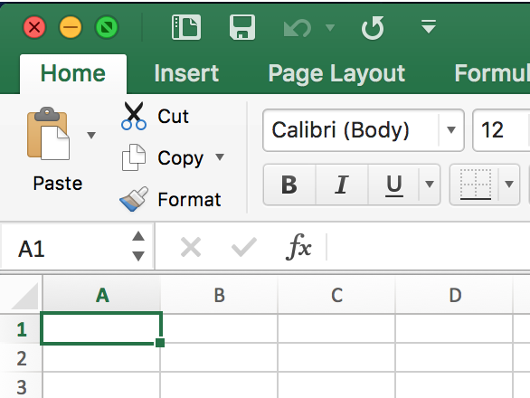

You’ll have to right click (or ***control + left click*** if you haven’t enabled secondary click) on the app’s icon in the dock, and click ***Quit*** (sometimes ***Force Quit***):

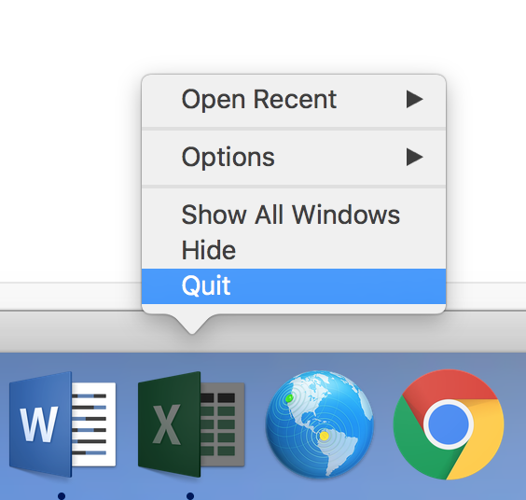 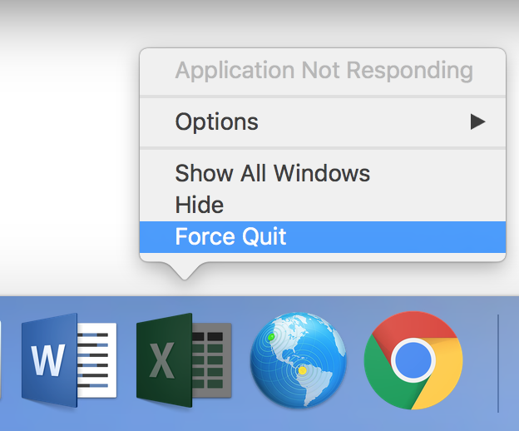

Alternatively, press ***option + command + Esc*** to bring out a list of running apps, choose the one that you want to close and click ***Force Quit***.

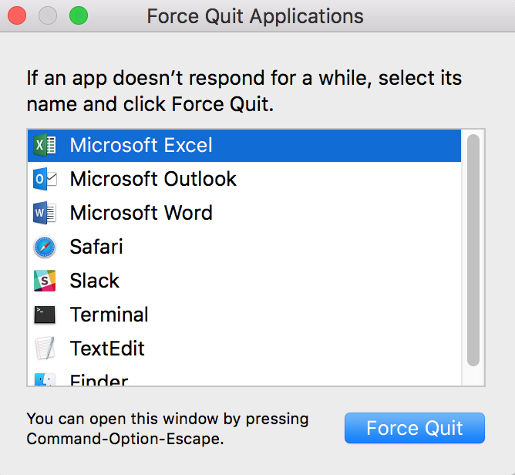

Then start it up again and see if it works. If not, call me.

# App keeps on freezing/crashing

While it’s not uncommon for an app (even the biggest named ones) to freeze or crash, it’s not easy to troubleshoot or fix other than restarting the app.

If the app crashes frequently that it causes nuisance, one thing you can try is to update the software version. Sometimes the crash could be due to a known bug that has been fixed in recent patches.

To update Mac OS or the apps downloaded from App Store, just go to ***App Store***: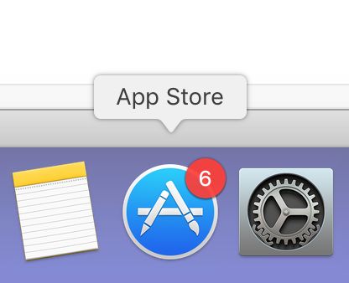

At the top row of the window, click ***Updates***:



Check if there’re updates available for OS, it’ll be shown at the top of the list, the X symbol means OS X:



Installing major updates for OS takes significantly long time, do this while you have time to spare.

If you downloaded your app from App Store, you will be able to update it here too:



If you downloaded the app somewhere else (e.g. acquired *.dmg file on a 3rd party website), then you may have to use the in-app updater or check out the official website whether there’s a new version available.

For exam Microsoft Office Suite offers an in-app updater, just goes to any Office app and, click ***Help*** and Check for ***Updates***:

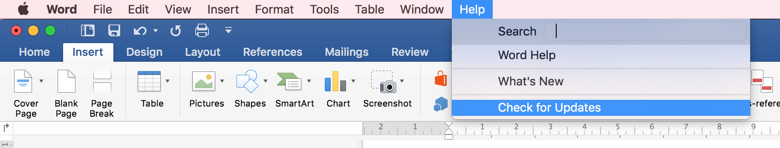

You may be asked to quite the Office apps while they’re being updated.

Another approach is to check whether you have peripherals connected to your Mac, like iPhone, iPod, USB/Thunderbolt adapters, external storage, etc. If you have, try to disconnect them all and see if the relevant app crashes again.

Sometimes a particular file can cause an app to crash. For example if your Word keeps freezing/crashing while you’re trying to open a document, it could be the reason that that file consists of contents that keep crashing the app (e.g. an incompatible font, improper formatting, too much data, etc.). In that case, try opening other files of similar type to isolate the problem (or avoid visiting the webpage that crashes your browser for that matter).

# Can’t find SERVER(AFP) in the Finder.

You want to access a shared drive in the server, but guess what the ***SERVER(AFP)*** entry is nowhere to be found in the Finder.

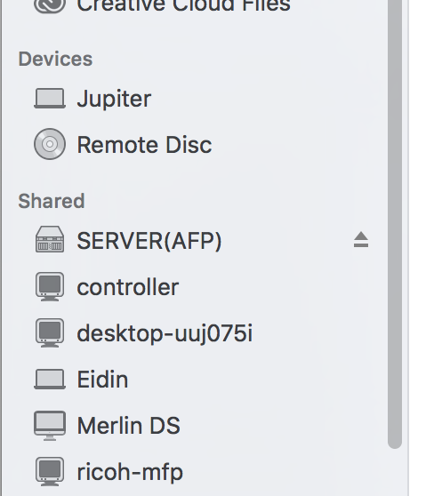

Sometimes that happen and the root cause is so far unknown (let me know if you run into this issue, I’d like to check further). But the fix is easy, just hold ***control + option*** and ***left click on Finder icon*** in the dock.

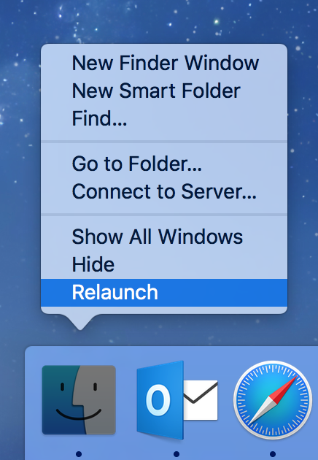

Click ***Relaunch***, then open Finder again, the server access is most probably there.

Alternatively, press ***option + command + Esc*** to bring out a list of running apps, choose Finder click ***Relaunch***.

# App can’t print 2-sided or A3 size.

A painful fact about Mac is that different apps seem to have different print settings, so if you want to alter the print settings it may be tricky in the first few trials.

***Word***:

Access printing interface by pressing ***command + p***, if “Copies & Pages” is shown in the 3rd field, click on it and choose ***Layout*** instead:

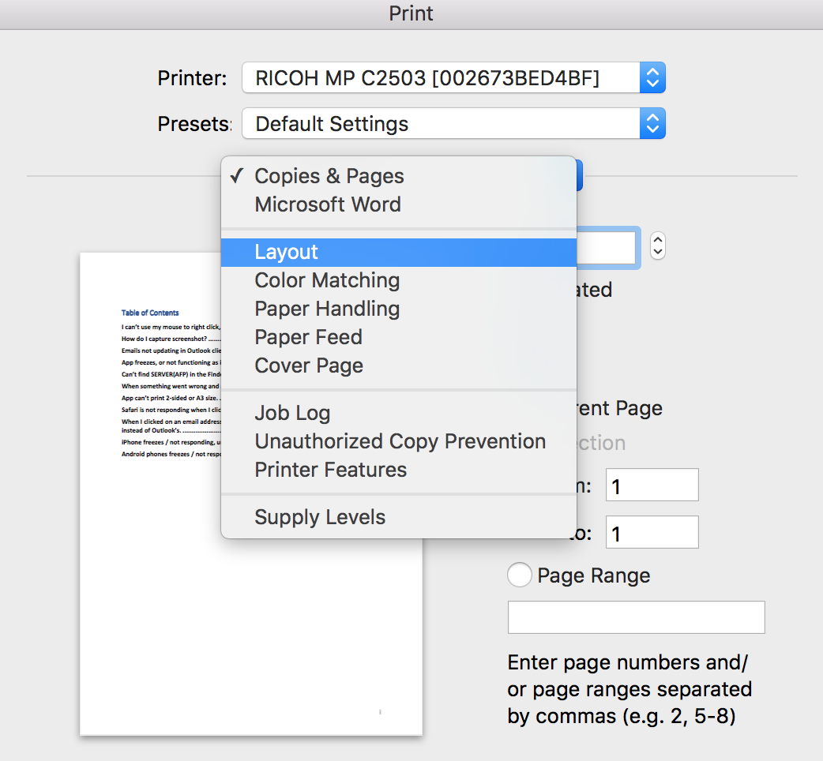

Now you can choose to print two-sided by selecting long or short edge binding:

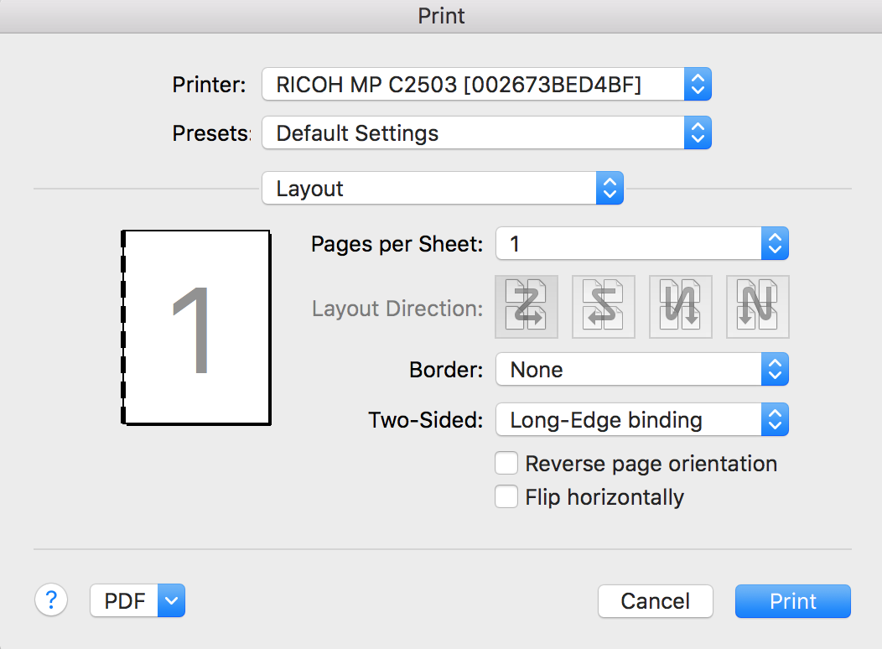

If you want to print in A3 size, in the same menu choose ***Paper Handling***, check ***Scale to fit paper size***, and choose A3:

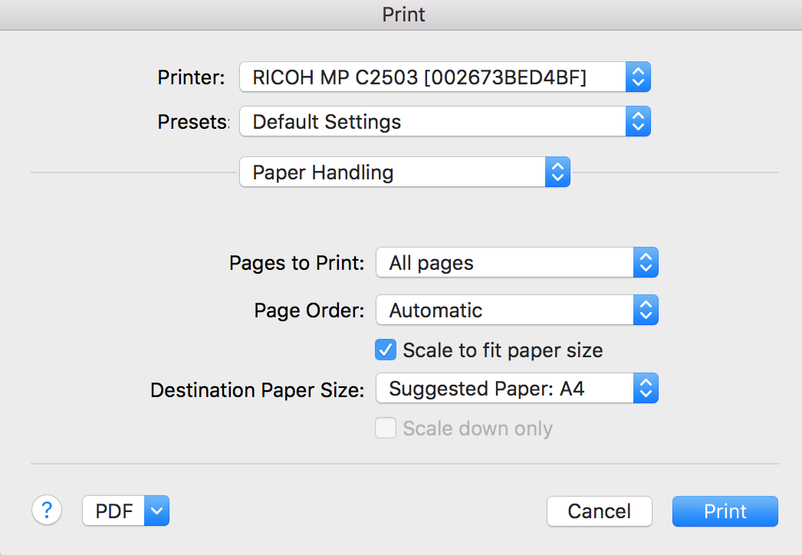

***Excel*** (also works for ***Safari***, ***Preview***):

While you tried to print, the ***Two-Sided*** checkbox should be available right away:

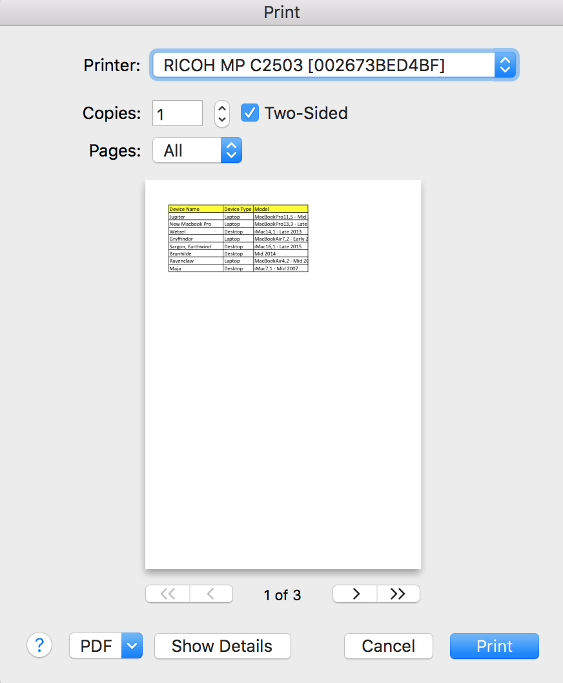

If you want more settings, including changing paper size, click ***Show Details***, paper size is available in the extended window:

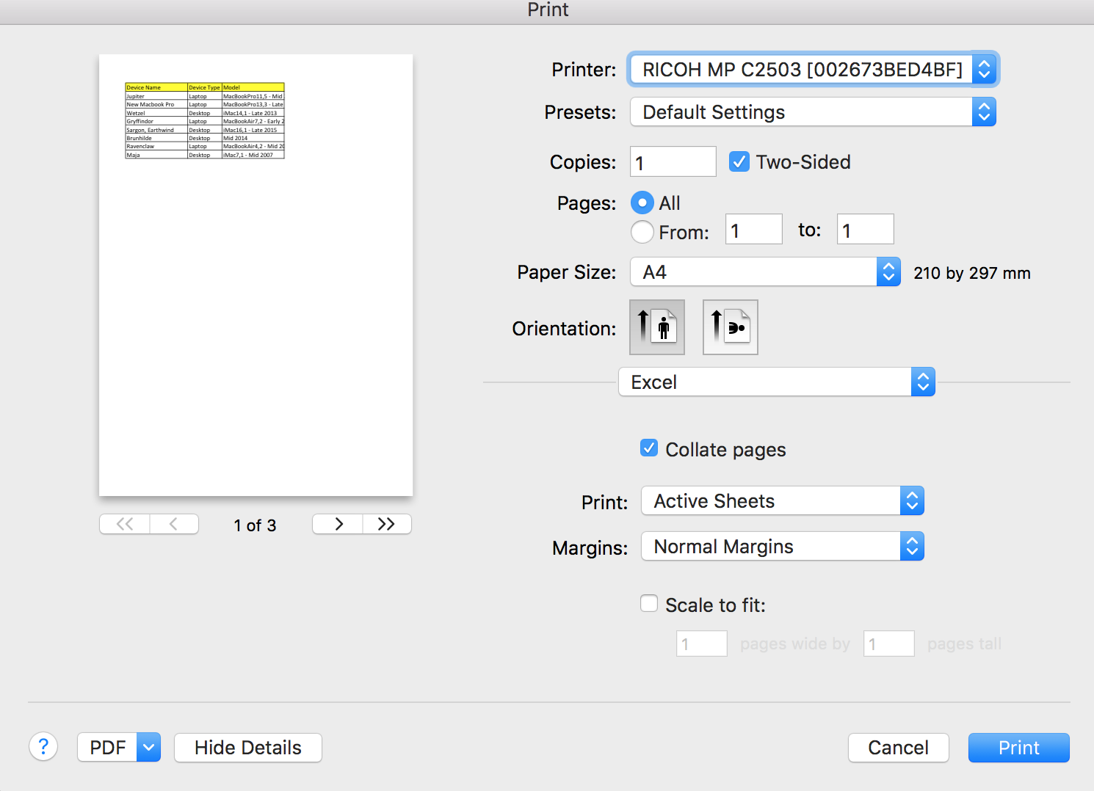

***Adobe Acrobat/Reader***:

While printing, try to find and check the ***Print on both sides of paper***:

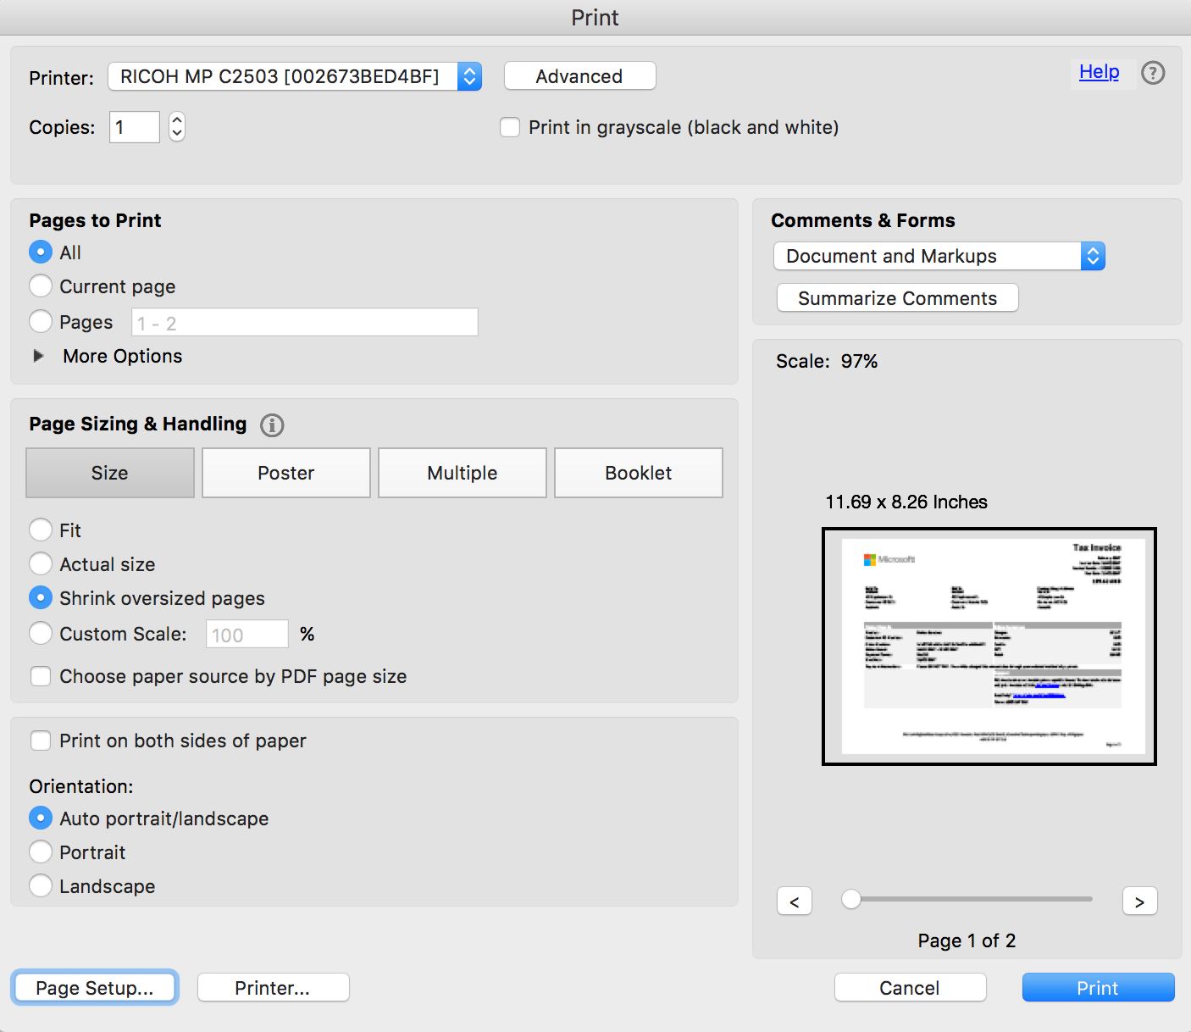

To change paper size, click Page Setup at the lower left corner:

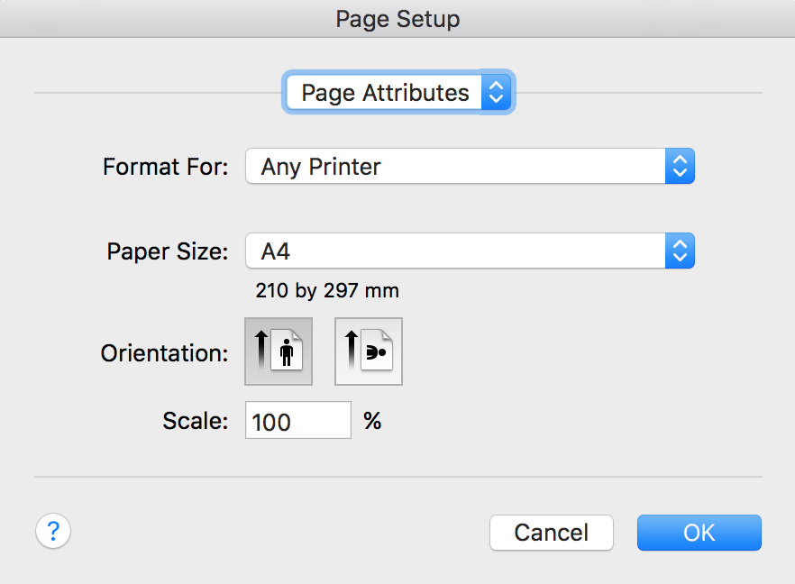

**Notes: If the options that you see on your Mac are different from the ones shown above, or is greyed out, you may need to remove and add your printer. Let me know and I’ll do this for you.**

# Safari is not responding when I click on a hyperlink.

If you’re clicking on a link on a website that is clearly a hyperlink but nothing happens, it could be the reason that the pop-up was blocked by Safari (what I don’t like is that Safari won’t even tell you that it has blocked a pop-up window).

You got two options:

1. Use another browser (Chrome, Firefox) to open the page, or;
2. Allow pop-up on Safari.

For option 2, while Safari window is active, click ***Safari 🡪 Preferences***:

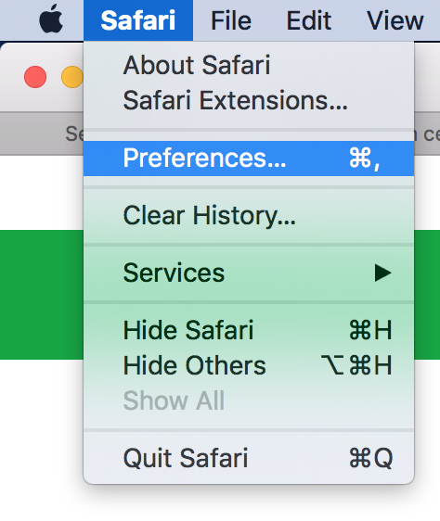

Go to ***Security*** tab, and uncheck the ***Block pop-up windows*** checkbox, then give it another try.

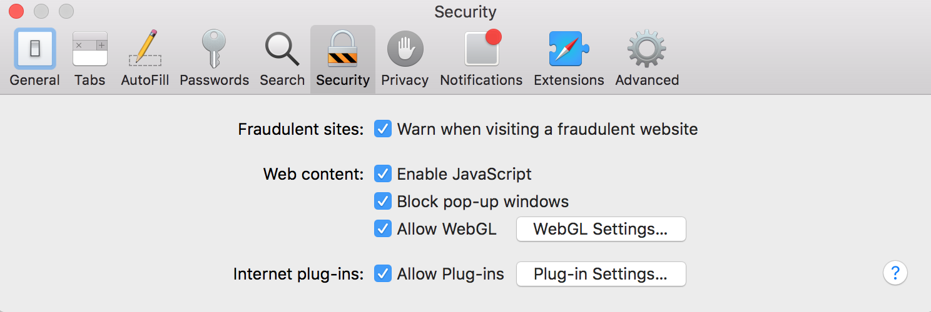

# When I clicked on an email address link on a website, it’s opened by Mail app composer instead of Outlook’s.

Sometimes you may see an email address link on a website and would like to mail to that address, but when you click on it, it was not Outlook composer that popped out. Instead it was Mac’s default Mail client:



Or if you have not setup the Mail client yet, it’ll just ask you to add an account:

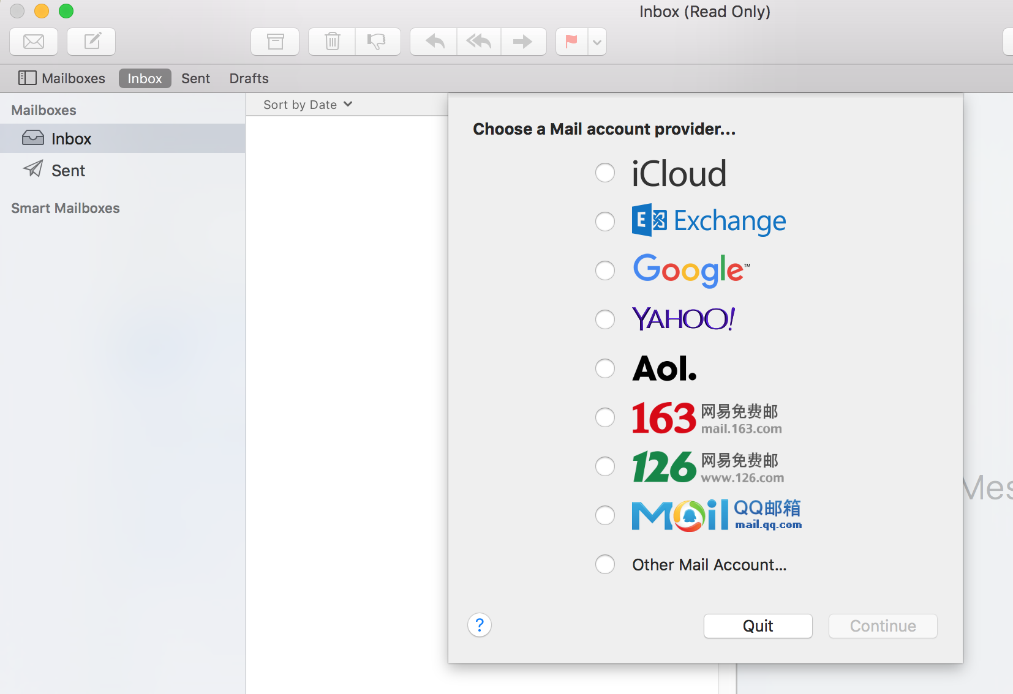

If Outlook is still your favourite mail client you can change the default mail client that the system uses.

Thing is the Mail app doesn’t allow you to change this setting unless you’ve added an account to the Mail app (ya, don’t ask me). So you can go ahead to add an email account, not necessarily Exchange, it can be your Google mail account.

Once added, you can go to ***Mail 🡪 Preferences*** page as below:

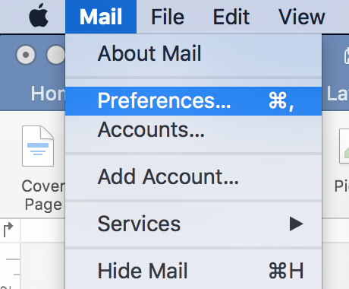

At the drop down menu of “Default email reader”, change it to Outlook:

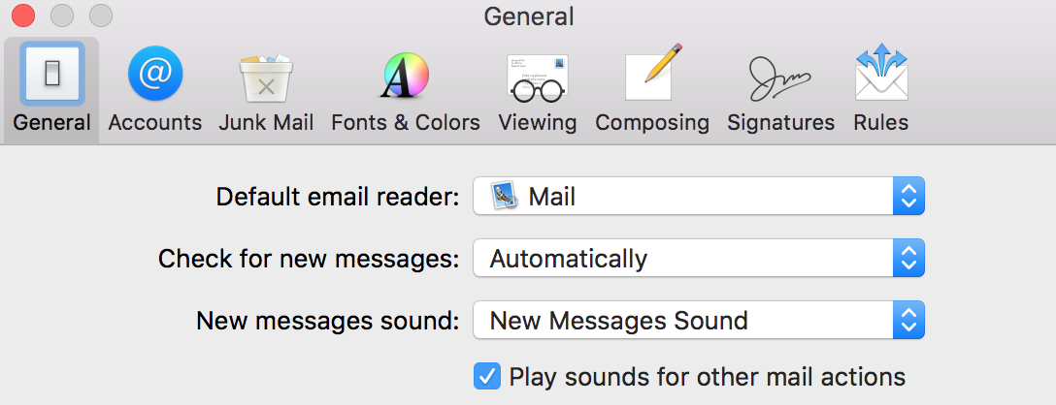

# iPhone/Android freezes / not responding, unable to start, restart or shutdown.

For iPhone:

* Hold the ***power button + home button*** for a few seconds, the phone should reboot.

For Android:

* If your phone has a removable battery, simple remove it and put it back then power up.
* If your phone battery is not accessible, hold the ***power button + volume down button*** for a few seconds, the phone should reboot.
* Phones from different manufacturers may have different key combinations or method, if that doesn’t work, do a quick search on Google or call me.

# When something went wrong and all above approaches failed.

If it’s not too much trouble for you, just reboot the device, regardless it’s a Mac or mobile device.

If the Mac refused to boot or you can’t even get to the Shut Down button, hold the power button of your Mac for a few seconds and it’ll go “poof”. Then click the power button again to start it up.

If your phone refused to reboot, check the related topic in this guidebook on how to do a hard reboot.

If the problem persists after reboot, call your best friend. ;)